**KL UNIVERSITY**

**FRESHMAN ENGINEERING DEPARTMENT**

PROJECT BASED ON LAB REPORT

ON

**Arduino LED Project for Ultrasonic Security System  
A MINI PROJECT REPORT**

***Submitted by:***

**Md Saif  
 *2100090144***

**KL UNIVERSITY**

Green fields, Vaddeswaram – 522502

Guntur Dt., AP, India   
March 2022

**DEPARTMEMNT OF BASIC ENGINEERING SCIENCES**

**CERTIFICATE**

This to certify that the project based laboratory report entitled “**Arduino LED Project for Ultrasonic Security System**” submited by Md Saif to the **Department of Basic Engineering Sciences, KL university** in partial fulfillment of the requirment for the completion of the project based laboratary in “Design Tools & Workshop-2” in 1 Betch 2 semester , is a bonafied record of the work carried out by him/her under my supervision during the acadimic year 2021-2022.

**Project supervisor Head of the department**

Ms. V Teju

**ACKNOWLEDGEMENTS**

It is a great pleasure for me to express my gratitude to our honourable President Sri. Koneru Satya Narayana, for giving the opportunity and platform with facilities in accomplishing the project-based report.

I pay my immense sense of gratitude laboratory to our Director Dr. A. Jagadeesh for his administration towards our academic growth. I express sincere gratitude to our Coordinator Dr. V. Krishna Reddy and Ms. V Teju for her leadership and constant motivation provided in the successful completion of our academic semester. I record it as my privilege to deeply thank you for providing us with the efficient faculty and facilities to make our ideas into reality.

I express my sincere thanks to our project supervisor for his novel association of ideas, encouragement, appreciation, and intellectual zeal which motivated us to venture into this project successfully. Finally, it is pleased to acknowledge the indebtedness to all those who devoted themselves directly or indirectly to making this project report success.

**ID NUMBER NAME**

2100090144 Md Saif

**ABSTRACT**

**Arduino LCD Project for Ultrasonic Security System**

**Author:** Md Saif(2100090144)  
Link to the project files:- bit.ly/DTW-project

**Introduction**

##### This is a simple alarm system made with help of buzzer, LED and an Ultrasonic sensor also known as Proximity/Distance Sensor (HC-SR04). One can stop the buzzer by pressing the button. Working this **Arduino Door Alarm** is very easy. Whenever anyone comes in the path/range of Ultrasonic Sensor, microcontroller detects the distance of object from the sensor and if the object is in the defined range, it sends the High signal to the buzzer and buzzer starts beeping. An Ultrasonic sensor is an instrument that measures the distance to an object using ultrasonic sound waves.

**Project Concept**

Connect a red wire from the 5V pin on the Arduino to the positive channel of the breadboard. Connect a black wire from the GND pin on the Arduino to the negative channel of the breadboard:

* buzzer = pin 7

On Ultrasonic Sensor:

* Echo = pin 3
* Trig = pin 2

LEDs:

* Red LED = pin 9
* Yellow LED = pin 10
* Blue LED = pin 11

The green wires connected to the LEDs should be connected in line to the positive side of the LED, while the negative side of the LED should be connected to the negative channel of the breadboard using a 220 ohm resistor.

#### ● FOR BREADBOARD

Firstly, let’s connect the 5V and GND pin on the Arduino to the breadboard. As I mentioned before, be sure that the wire attached to the 5V pin is connected to the positive channel of the breadboard, and the wire attached to the GND pin is connected to the negative channel of the breadboard.

#### ● FOR ULTRASONIC SENSOR

Time to connect the HC-SRO4 ultrasonic sensor! A great tip is to place the ultrasonic sensor as far right to the breadboard as possible and make sure that it is facing out. Referring back to the setup picture, you should connect the GND pin on the ultrasonic sensor to the negative channel on the breadboard. Next connect the Trig pin on the sensor to pin 2 on the Arduino and connect the Echo pin on the sensor to pin 3 on the Arduino. Lastly, connect the VCC pin on the ultrasonic sensor to the positive channel on the breadboard. Refer to the picture above if anything gets confusing.

#### ● FOR LEDs

The next step is to connect the LED’s to the breadboard and Arduino. If you need to, I highly recommend that you refer back to the setup picture (Step 2), attaching the LEDs is pretty easy, there’s a lot of repetition. Let’s first attach the Green LED. So the way to do this is to connect the anode (the longer leg) to pin 6 on the Arduino with a green wire, and to connect the cathode (the shorter leg) to the negative channel on the breadboard, using a 220 ohm resistor. Then repeat that step for the Yellow and then the Red LED make sure to connect the anode (the longer leg) of the yellow LED to pin 5 on the Arduino and then connect the anode of the red LED to pin 6. Once you have done that, your setup should look similar to the picture above.

Resistors are not absolutely necessary, however they are highly recommended to be used.

#### ● FOR BUZZER

The last part of the setup for this is connecting the buzzer to the breadboard and the Arduino. This is one of the easiest parts of the whole setup. All that is required to do is to connect the longer leg of the buzzer to pin 7 of the Arduino using a green wire and then connect the shorter leg of the buzzer to the negative channel of the breadboard using a 221 ohm resistor.

It is HIGHLY recommended to use a resistor in connecting the shorter leg of the buzzer to the negative channel of the breadboard. This greatly reduces the volume of the buzzer and prevents it from dying too quickly.

**Apparatus required**

* Arduino Uno
* LED
* Ultrasonic Sensor
* Piezo buzzer
* Breadboard
* Jumper Wires
* Resistor 221ohm

## **Working Principle**

The ultrasonic sensor emits an ultrasonic wave from the trigger which comes back after hitting the object and it is received by the echo. The echo will then tell us the distance travelled in microseconds. To send an ultrasonic wave from the trigger, we will have to set the trigger high for 10us. This will send an 8 cycle sonic burst at 40 kHz which will hit the object and is then received by the echo.

We have got the time in microseconds but we need to calculate the distance. So, we will use the equation below.

**S = v * t**

We have the value of **t** and we know that the speed of a sound wave is 340m/s. We have to convert the speed of sound into cm/us to calculate the distance. The speed of sound in cm/us is 0.034cm/us. The equation now will become …

**S = (0.034 * t)**

We will divide this equation by 2 because we only require the distance it takes to hit the object and not the distance it takes to hit the object and come back. So, the final equation will be

**S = (0.035 * t)/2**

We will get the distance value using the equation above and after that, we will set a value which will help us make the [buzzer](https://www.technodudes.in/autonomous-parking-system/) high or low.

**Circuit Diagram**

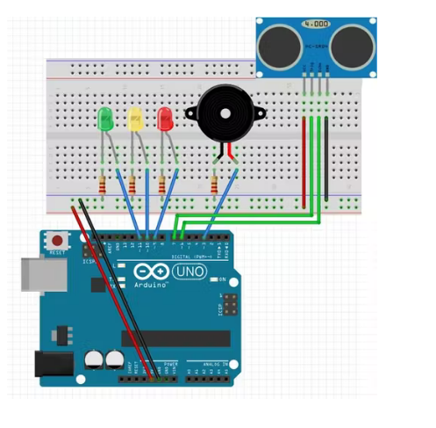

**Figure:**

### Step 1: Assemble Materials

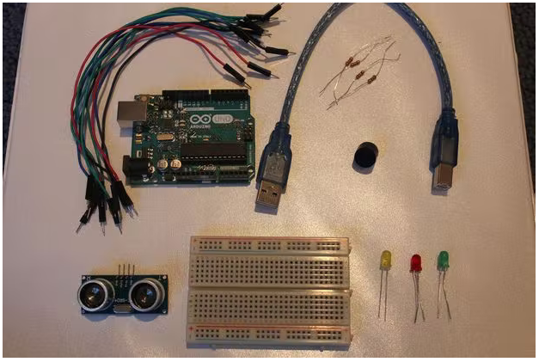

### Step 2: Assembly - Breadboard

[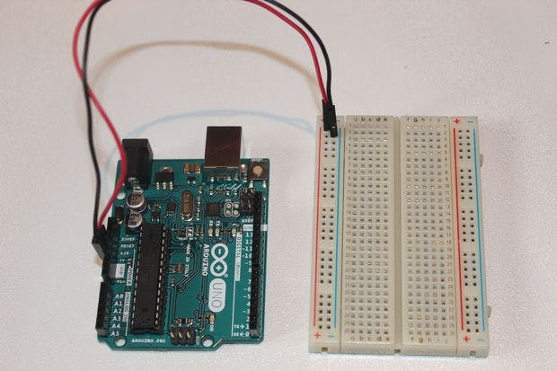](javascript:openLightBox('43110e5bbd',%200);)

### Step 3: Assembly - Ultrasonic Sensor

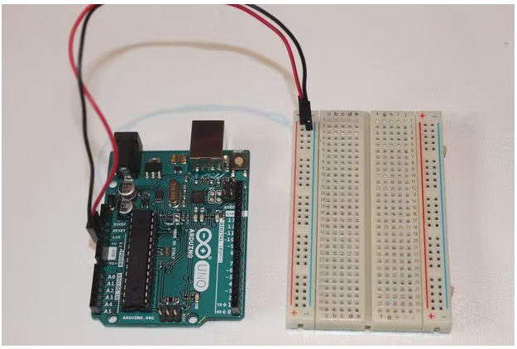

### Step 4: Assembly - LEDs

[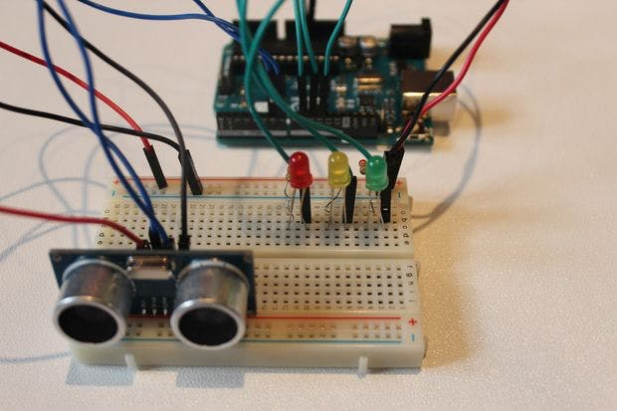](javascript:openLightBox('aed6ad5025',%200);)

### Step 5: Assembly - Buzzer

[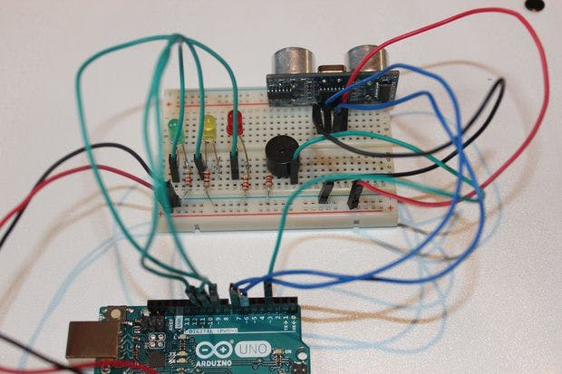](javascript:openLightBox('482170510f',%200);)

**Final circuit**

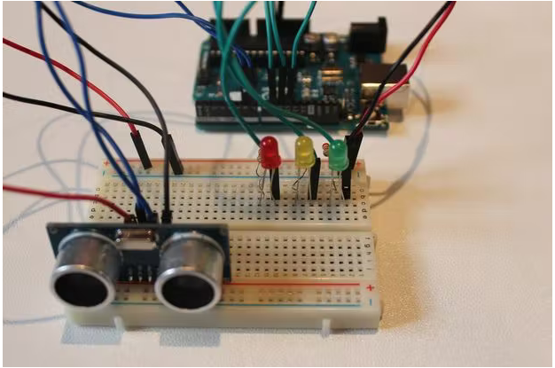

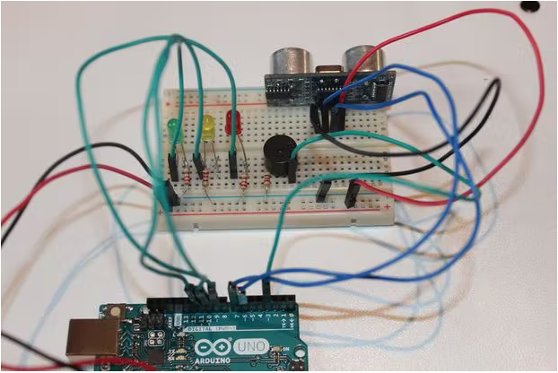

***CODE:***

const int trigPin = 2;  
const int echoPin = 3;  
const int LEDlampRed = 4;  
const int LEDlampYellow = 5;  
const int LEDlampGreen = 6;  
const int buzzer = 7;  
int sound = 500;

void setup() {  
Serial.begin (9600);  
pinMode(trigPin, OUTPUT);  
pinMode(echoPin, INPUT);  
pinMode(LEDlampRed, OUTPUT);  
pinMode(LEDlampYellow, OUTPUT);  
pinMode(LEDlampGreen, OUTPUT);  
pinMode(buzzer, OUTPUT);  
}  
void loop() {  
long durationindigit, distanceincm;  
digitalWrite(trigPin, LOW);  
delayMicroseconds(2);  
digitalWrite(trigPin, HIGH);  
delayMicroseconds(10);  
digitalWrite(trigPin, LOW);  
durationindigit = pulseIn(echoPin, HIGH);  
distanceincm = (durationindigit * 0.034) / 2;

if (distanceincm > 50) {  
digitalWrite(LEDlampGreen, LOW);  
digitalWrite(LEDlampYellow, LOW);  
digitalWrite(LEDlampRed, LOW);  
noTone(buzzer);  
}  
else if (distanceincm <= 50 && distanceincm > 20) {  
digitalWrite(LEDlampGreen, HIGH);  
digitalWrite(LEDlampYellow, LOW);  
digitalWrite(LEDlampRed, LOW);  
noTone(buzzer);  
}  
else if (distanceincm <= 20 && distanceincm > 5) {  
digitalWrite(LEDlampYellow, HIGH);  
digitalWrite(LEDlampGreen, HIGH);  
digitalWrite(LEDlampRed, LOW);  
tone(buzzer, 500);  
}  
else if (distanceincm <= 0) {  
digitalWrite(LEDlampGreen, LOW);  
digitalWrite(LEDlampYellow, HIGH);  
digitalWrite(LEDlampRed, LOW);  
noTone(buzzer);  
}  
else {  
digitalWrite(LEDlampGreen, HIGH);  
digitalWrite(LEDlampYellow, HIGH);  
tone(buzzer, 1000);  
digitalWrite(LEDlampRed, HIGH);  
delay(300);  
digitalWrite(LEDlampRed, LOW);  
}

Serial.print(distanceincm);  
Serial.println(" cm");

delay(300);  
}

**FINAL:**

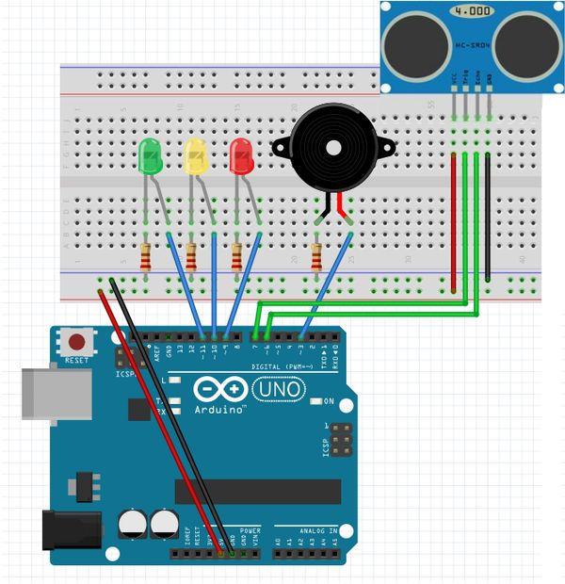

**THANK YOU!**